

**Software Project Report On**

**BAMBOO PRODUCT SELLING SYSTEM**

**Submitted to**



# Savitribai Phule Pune University Developed By

**Ms.Pranali Anil Gaikwad**

**Ms.Bhavana Bhavarlal Bhati**

In the partial fulfillment of the degree of

**BBA-CA Sem-V**

**(2025-2026)**

**Under the Guidance Of**

**Prof. G.S. Swami**

**Prof. M. Y. Khairnar Prof. D.S. Jambhulkar**

**Pune District Education Association’s**

**Baburaoji Gholap College, Sangvi, Pune-411027.**

**Department of Computer Application**



**P.D.E.A’s**

**Baburaoji Gholap College, Sangvi, Pune - 27. Department of Computer Application**

# Certificate



**Savitribai Phule Pune University**

This is to certify that, **Miss: Pranali Anil Gaikwad** **Class- TYBBA-CA , Roll**

**No. 3616** has satisfactorily completed the project under the subject “

**Software Project-II** ” having the title “**Bamboo Product Selling System**”.

As laid down by the Savitribai Phule Pune University during the year

2025-2026

Seat No.___________

**Project Guide Head of Department**

**Internal Examiner External Examiner**



**P.D.E.A’s**

**Baburaoji Gholap College, Sangvi, Pune - 27. Department of Computer Application**

# Certificate



**Savitribai Phule Pune University**

This is to certify that, **Miss:Bhavana Bhavarlal Bhati**  **Class- TYBBA-CA ,**

**Roll No. 3617** has satisfactorily completed the project under the subject

“ **Software Project-II** ” having the title “**Bamboo Product Selling System**”.

As laid down by the

Savitribai Phule Pune University during the year 2025 - 2026

Seat No.___________

**Project Guide Head of Department**

**Internal Examiner External Examiner**

**ACKNOWLEDGEMENT**

I would like to take this opportunity to express my sincere gratitude to everyone who has supported and guided me in completing this project on “**Bamboo Product Selling System**.” This project would not have been possible without the encouragement, help, and valuable suggestions of many people.

First of all, I would like to thank my teachers and mentors for their constant guidance, valuable advice, and motivation throughout the development of this project. Their encouragement has helped me in understanding the subject deeply and applying it practically.

I am also thankful to my friends and classmates who have supported me by sharing ideas, discussing problems, and encouraging me during different stages of the project work. Their cooperation has been a great source of strength for me.

I would also like to express my gratitude to my family members for their love, patience, and continuous support. Their understanding and encouragement have given me the confidence to complete this project successfully.

Lastly, I acknowledge all the authors, researchers, and online resources whose work and knowledge have been very helpful in designing and preparing this project.

This project has given me a chance to enhance my knowledge, improve my technical skills, and understand the importance of teamwork, patience, and dedication. I feel proud to have completed this project and I am thankful to everyone who has been a part of this journey.

# INDEX

|  |  |  |
| --- | --- | --- |
| **Sr.No** | **Content** | **Page no** |
| **1** | **Abstract** | **1** |
| **2** | **Introduction** |  |
| **3** | motivation |  |
| **4** | problem statement |  |
| **5** | purpose/objective and goals |  |
| **6** | literature survey |  |
| **7** | project scope and limitations |  |
|  |  |  |
| **8** | **System analysis** |  |
| **9** | Existing systems |  |
| **10** | scope and limitations of existing systems |  |
| **11** | project perspective, features |  |
| **12** | stakeholders |  |
| **13** | Requirement analysis - Functional requirements, performance requirements, security requirements etc. |  |
|  |  |  |
| **14** | **System Design** |  |
| **15** | Design constraints |  |
| **16** | System Model: DFD |  |
| **17** | Data Model |  |
| **18** | User interfaces |  |
|  |  |  |
| **19** | **Implementation details** |  |
| **20** | Software/hardware specifications |  |
|  |  |  |
| **21** | **Outputs and Reports Testing** |  |
| **22** | Test Plan, Black Box Testing or Data Validation  Test Cases, White Box Testing or Functional  Validation Test cases and results |  |
|  |  |  |
| **23** | **Conclusion and Recommendations** |  |
| **24** | **Future Scope** |  |
| **25** | **Bibliography and References** |  |

# 1. Abstract

This project focuses on creating a structured system for producing, marketing, and selling eco-friendly bamboo products.

Bamboo is a fast-growing and renewable resource that can replace harmful non-biodegradable materials like plastic.

The system includes raw material sourcing, processing, distribution, marketing, and sales management.

Products cover categories such as furniture, home décor, kitchenware, packaging, stationery, clothing, and handicrafts.

The target market includes eco-conscious consumers, urban households, hotels, restaurants, and exporters.

By adopting bamboo, we not only create profitable business opportunities but also promote sustainability, reduce plastic waste, and support farmers.

This system ensures a balance between economic growth and environmental protection or a better future.

# 2. Introduction

A bamboo product selling system is a framework for producing, marketing, and distributing products made from one of the world's most sustainable and versatile plants. The system encompasses the entire value chain, from cultivating bamboo and processing the raw material to selling finished goods like furniture, kitchenware, textiles, and building materials to consumers.

This business model capitalizes on the global movement toward ecofriendly, biodegradable alternatives to plastic, wood, and other less sustainable materials. Technological advances in areas like composites and automation are enabling the creation of high-quality products that are both aesthetically appealing and functional, moving bamboo's image from "the poor man's timber" to a modern, viable material.

**2.1 Motivation:**

Bamboo is a natural gift – it grows fast, is biodegradable, and safe for future generations.

If we make small changes – like using a bamboo toothbrush instead of plastic, or a bamboo straw instead of plastic straw – we can create a big positive impact.

Sustainability means meeting our needs today without harming tomorrow.

So, let’s take a step towards a Plastic-Free India and choose bamboo for a greener future.”

The motivation behind this project stems from the growing global concern over climate change, plastic pollution, and environmental degradation. Bamboo, as a renewable and biodegradable resource, presents itself as a sustainable alternative to plastic and wood. Despite its benefits, bamboo product sellers face challenges in reaching wider markets. A digital selling system tailored for bamboo products can empower artisans, promote sustainability, and bridge the gap between rural craftsmanship and urban/global consumers.

**2.2 Problem Statement:**

1. Overuse of Plastic → Causes Pollution

Plastic has become a major environmental concern because it is nonbiodegradable and remains in the ecosystem for hundreds of years.

Excessive use of plastic bags, bottles, packaging materials, and other products contributes to soil, water, and air pollution.

The dependency on plastic continues to rise due to its cheap cost and convenience, but alternatives are not promoted strongly enough.

1. Deforestation due to Wood Furniture and Products

Large-scale cutting of trees for wood-based furniture, paper, and household products is leading to deforestation.

This results in loss of biodiversity, disruption of ecosystems, and contributes significantly to climate change.

1. Unorganized Bamboo Market → Farmers Don’t Get Fair Trade

Bamboo farming is mostly done by small-scale farmers,but the market is highly unorganized.

Farmers often sell raw bamboo at very low prices due to lack of proper supply chain, storage, and processing units.

Middlemen exploit farmers by purchasing at cheap rates and selling at high margins.

This results in farmers not receiving fair trade benefits despite bamboo’s high potential in domestic and international markets.

1. Lack of Awareness → People Don’t Know Bamboo Can Replace

Many Items

A large section of society is unaware of bamboo’s versatility as an eco-friendly alternative.

Bamboo can replace plastics (cups, straws, bottles), wood (furniture, flooring), steel (scaffolding, construction materials), and even fabrics (bamboo textiles).

Many consumers associate bamboo only with traditional uses (like baskets or mats) and are not informed about modern innovations in bamboo products.

Lack of promotional campaigns, educational programs, and demonstrations has led to poor consumer awareness.

Without awareness, demand remains low.

**2.3 Objectives and Goals:**

1. Support Farmers: By Buying Bamboo Directly

We want to help bamboo farmers by buying bamboo straight from them. This way, farmers earn more money because there is no middleman taking a cut. Supporting farmers also encourages them to grow more bamboo, which helps local communities.

1. Eco-Friendly Alternative: Replace Plastics

Bamboo products are natural and good for the environment. By using bamboo instead of plastic, we can reduce pollution and protect the planet. This system helps people choose eco-friendly products easily.

1. Awareness: Educate Customers

Many people do not know how bamboo products help the environment. We want to educate customers about the benefits of bamboo and how using it is better than plastic. This will help more people support sustainable products.

1. System Creation: Structured Production → Marketing → Selling

We aim to create a clear system for making, selling, and marketing bamboo products. This helps the whole process run smoothly, saves time, and makes it easier for farmers and customers

* Provide an online platform dedicated to bamboo products.
* Support artisans and small-scale sellers to expand their reach.
* Enable secure online transactions with integrated payment systems.
* Improve customer experience with an intuitive interface.
* Promote eco-friendly living and sustainability.
* Provide data insights for better sales and inventory management.

**2.4 Literature Survey:**

1. Bamboo Mission by Government of India

The government started the Bamboo Mission to help farmers and small businesses. It gives training, money, and support to grow bamboo and make products from it. It is very active in the North-East. 2. Bamboo in North-Eastern

States (Assam, Tripura, Mizoram)

Bamboo is used a lot in the North-East. In Assam, people make flutes and handicrafts. In Tripura, bamboo plantations help farmers earn money. In Mizoram, bamboo factories give jobs and make products that sell well.

2.Successful Bamboo Startups

Some bamboo businesses in India are doing very well. Villages with bamboo forests started small businesses and now earn more money. They also give jobs to local people.

3. Bamboo Market Growth

The bamboo market in India is growing very fast, around 20–25% every year. People are using bamboo instead of plastic. Bamboo is used for furniture, clothes, and many other products.

Existing e-commerce platforms like Amazon, Flipkart, and Etsy support a variety of products, including bam boo. However, they are not specialized for eco-friendly or sustainable products. Studies show that niche platforms improve product visibility, enhance customer trust, and provide targeted marketing. Research also emphasizes that government policies and initiatives are promoting bamboo-based industries as part of sustainable development goals.

**2.5 Scope and Limitations:**

**Scope:**

The scope of the Bamboo Products Selling System includes:

* Online Marketplace: Creating a digital platform for buying and selling bamboo products, connecting artisans and producers with customers.
* Product Range: Showcasing a variety of bamboo products, including handicrafts, furniture, home decor items, and more.
* Geographic Reach: Potentially targeting a global customer base, while also catering to local markets.
* Artisan Support: Providing features and tools to support artisans and producers in showcasing and selling their products.
* Sustainable Practices: Promoting sustainable bamboo products and practices, contributing to environmental conservation.
* Online selling platform for bamboo products.
* Provides space for artisans, manufacturers, and retailers.
* Integrates inventory, order, and payment management. - Supports scalability for other eco-friendly products.

**Limitations:**

* Awareness Gap: Many people may not know about the website or the benefits of bamboo products, so fewer people may visit or buy from the site.
* Competition with Cheap Materials
* Bamboo products are eco-friendly but sometimes cost more than plastic or other cheap alternatives, so some customers may avoid buying.
* No Online Payment Facility: The website only supports offline/cash payments. Customers cannot pay online, which may reduce convenience and sales.

# 3.System Analysis

**3.1 Existing Systems and their Limitations:**

Existing systems for product selling include large-scale e-commerce platforms such as Amazon, Flipkart, and Etsy. These platforms offer a wide variety of products but lack specialization for bamboo.

Challenges include:

* Sellers face high competition.
* Customers find it difficult to search authentic bamboo products.
* Artisans face difficulty in meeting platform requirements. - Lack of direct marketing tools for eco-friendly branding.

**3.2 Project Perspective and Features:**

The Bamboo Product Selling System provides a specialized marketplace with the following features:

The bamboo selling website is designed to make the entire bamboo business organized and easy. Some key features are:

Sourcing Raw Bamboo

The system helps collect bamboo directly from farmers.

Farmers can list the bamboo they have, and the website keeps track of availability.

Processing and Making Products

The raw bamboo is sent to manufacturers or workshops.

The system records which products are made, their quantity, and details.

Selling Through Online Channels

Customers can buy bamboo products through the website (offline payment).

Retailers and shops can also get products through orders placed online.

Educate customers about the benefits of bamboo.

Customer Benefits

Easy access to eco-friendly bamboo products.

Transparency in product details and pricing.

Supports local farmers and sustainable businesses.

**3.3 Stakeholders:**

## 1.Farmers

Farmers grow bamboo and supply raw material. They benefit by getting fair prices and support from the system. The website helps connect them directly with manufacturers and customers.

### 2. Manufacturers

They process bamboo into products like furniture, utensils, and handicrafts. The system tracks production, inventory, and orders, making manufacturing more organized.

### 3. Distributors

Distributors transport bamboo products from manufacturers to shops or customers. The website helps track orders and delivery schedules for smooth logistics.

### 4. Retailers

Retailers sell bamboo products to customers in local markets or shops. They can order products through the website and keep track of stock.

### 5. Customers

Customers buy eco-friendly bamboo products. They benefit from knowing product details, supporting farmers, and using sustainable products.

### 6. Government

The government supports bamboo farming and businesses through schemes like the National Bamboo Mission. They ensure regulations and provide financial or technical support.

**3.4 Requirement Analysis:**

## Functional Requirements

Allow farmers to list and update bamboo stock.

Enable manufacturers to track production and inventory.

Manage orders from retailers and customers.

Track deliveries and logistics.

Provide basic CRM to handle customer details and queries.

## Performance Requirements

The system should run smoothly without errors.

Order processing, stock updates, and delivery tracking should be fast.

Pages and product listings should load quickly for users.

## Security Requirements

Customer data like name, address, and contact should be safe.

Trade data like order details, prices, and stock must be protected.

Prevent unauthorized access to the website or sensitive information.

# 4. System Design

The system design involves architectural diagrams, ER diagrams, and interface mockups. It focuses on modular design to ensure scalability, usability, and maintainability.

**4.1 Design Constraints:**

Here’s a simple and detailed version of your System Design section for your bamboo selling website project. I’ve broken it down so it’s easy to understand and suitable for a report.

## 1. High Transport Cost

Bamboo is bulky and heavy, which makes transporting it from farms to processing units and then to customers costly. The system must consider these costs while managing orders and delivery schedules.

## 2. Lack of Awareness

Many people do not know about bamboo products or their benefits. This makes it harder to attract customers to the website. Extra effort is needed for marketing and educating people about

eco-friendly products.

**3. Competition with Plastics**

Plastic products are cheaper and easily available. Bamboo products are more expensive, so the website must highlight the benefits of bamboo to convince customers to buy.

**4.2 System Model (Data Flow Diagrams):**

Data Flow Diagrams (DFDs) show how data moves in the system

**Level 0 DFD:**

R

equest

Register

/login

R

e

g

ister

confirmation

M

anages

product/categor

y

R

eport,

updates

0.0

B

amboo

P

roduct

S

elling

S

ystem

C

ustomer

Admin

**Level 1 DFD**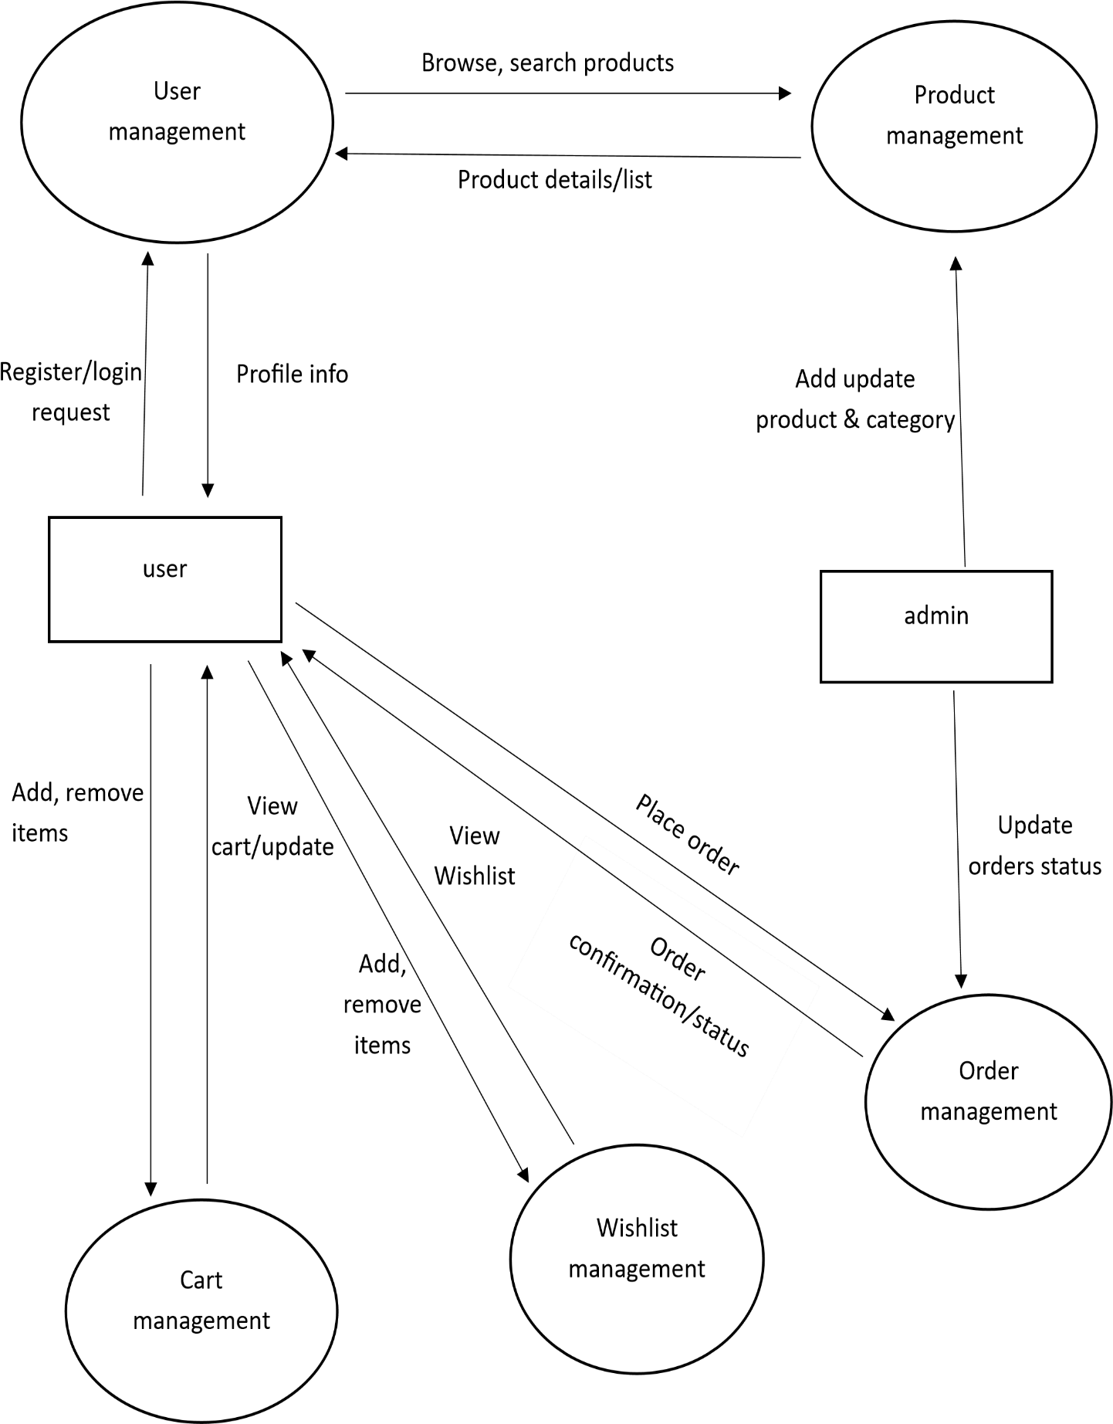

**Level: 2 DFD**

Update order status

Admin

Product list/details

Confirmation /error

View cart

Order database

*Order Confirmation / Status*

Save order

Place order

View Wishlist

Update

Wishlist database

Add/Remove items

update

Cart database

Add/Remove items

Browse/

search request

Fetch data

Product database

Verify details

Login request

User database

Customer

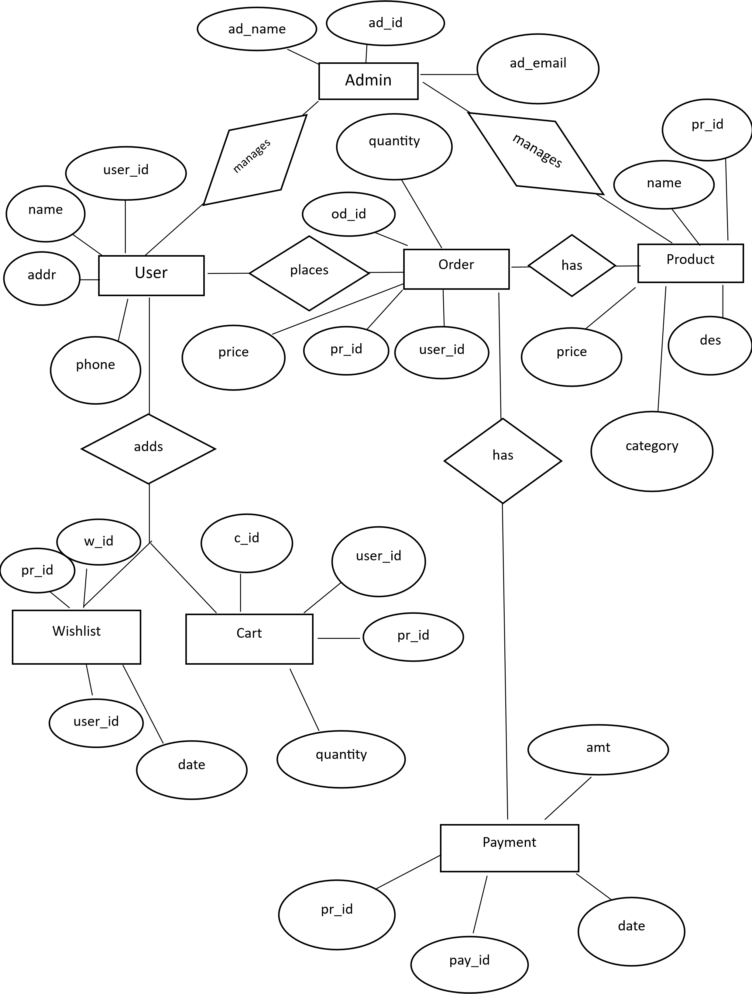**4.3 ER** **Diagram:**

**4.4 Data Model:**

## **1. User**

**Attributes:**

* user_id (Primary Key)
* name
* addr
* phone

**Relationships:**

* One user can place many orders (1→M).
* One user can add many products to wishlist (1→M).
* One user can add many products to cart (1→M).

## **2. Order**

**Attributes**:

* od_id (Primary Key)
* quantity
* user_id (Foreign Key → User) * pr_id (Foreign Key → Product)

**Relationships:**

* One order contains one product, but one product can appear in many orders (M→1).
* One order can have many payments (1→M).
* One order belongs to only one user (M→1).

## **3. Product**

**Attributes**:

* pr_id (Primary Key)
* name
* price
* des (description)
* category

**Relationships:**

* One product can be part of many orders (1→M).
* One product can appear in many wishlists (1→M).
* One product can be added to many carts (1→M).
* One product can have many payments (1→M).

## **4. Wishlist**

**Attributes**:

* w_id (Primary Key)
* date
* user_id (Foreign Key → User) pr_id (Foreign Key → Product) **Relationships**:
* One user can create many wishlist entries (1→M).
* One product can be added to many users’ wishlists (1→M).

## **5. Cart**

**Attributes**:

* c_id (Primary Key)
* date
* quantity
* user_id (Foreign Key → User) pr_id (Foreign Key → Product) **Relationships**:
* One user can add many items to the cart (1→M).
* One product can appear in many carts (1→M).

## **6. Payment**

**Attributes**:

* pay_id (Primary Key)
* date
* amt (amount)
* pr_id (Foreign Key → Product) od_id (Foreign Key → Order)

**Relationships:**

* One order can have many payments (1→M).
* One product can be linked to many payments (1→M).

## **7. Admin**

**Attributes**:

* ad_id (Primary Key)
* ad_name
* a _email

**Relationships:**

* One admin can manage many products (1→M).
* One admin can manage many orders (1→M).

**4.5 User Interfaces:**

The website and mobile app have simple and user-friendly pages:

## 1. Home Page

Shows the company logo, navigation menu, and banner

.Highlights popular products, offers, and eco-friendly message.

* Provides easy links to products, contact, and about pages.

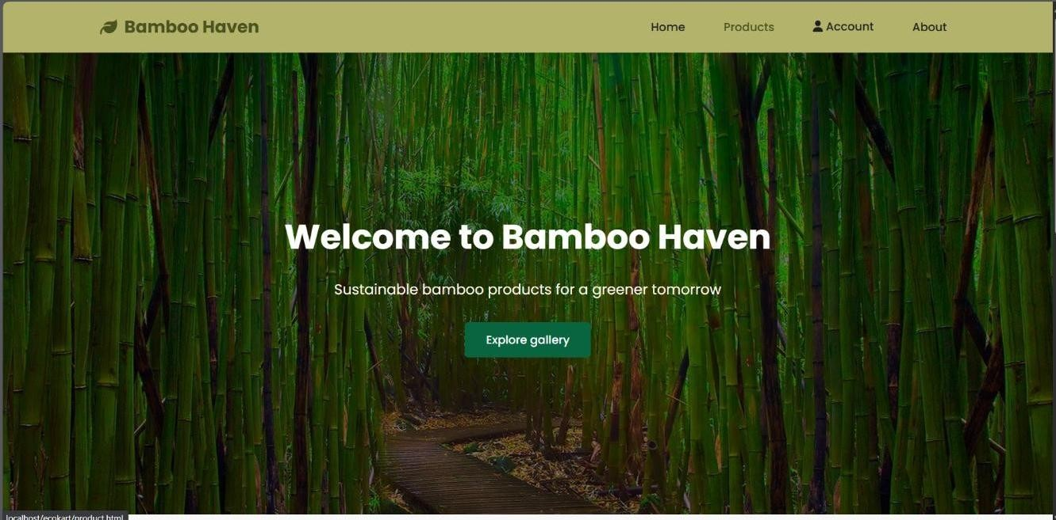

## 2. Products Page

* Displays all bamboo products with images, price, and short description.
* Allows filtering by category, price, or popularity.
* Users can click on a product to see detailed description.
* 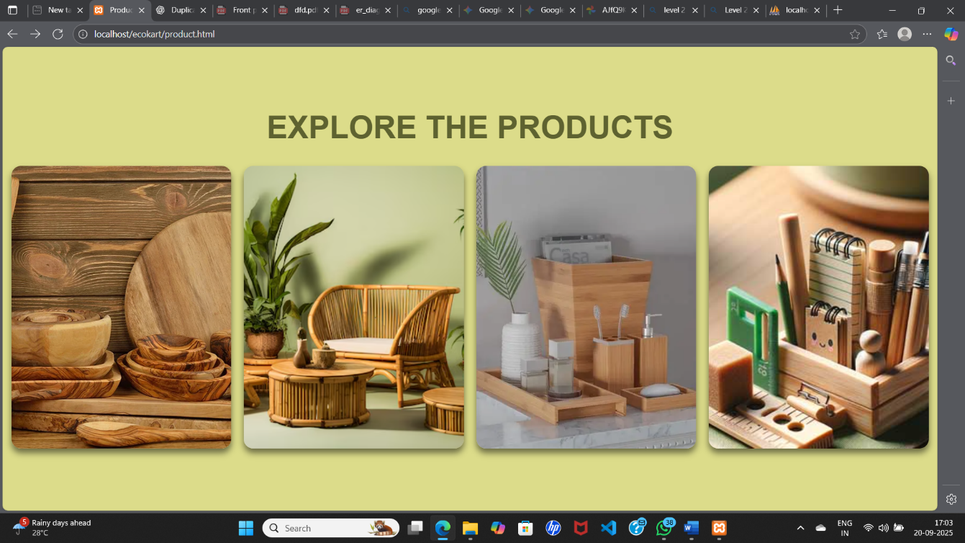Product Categorise page:
* Product page

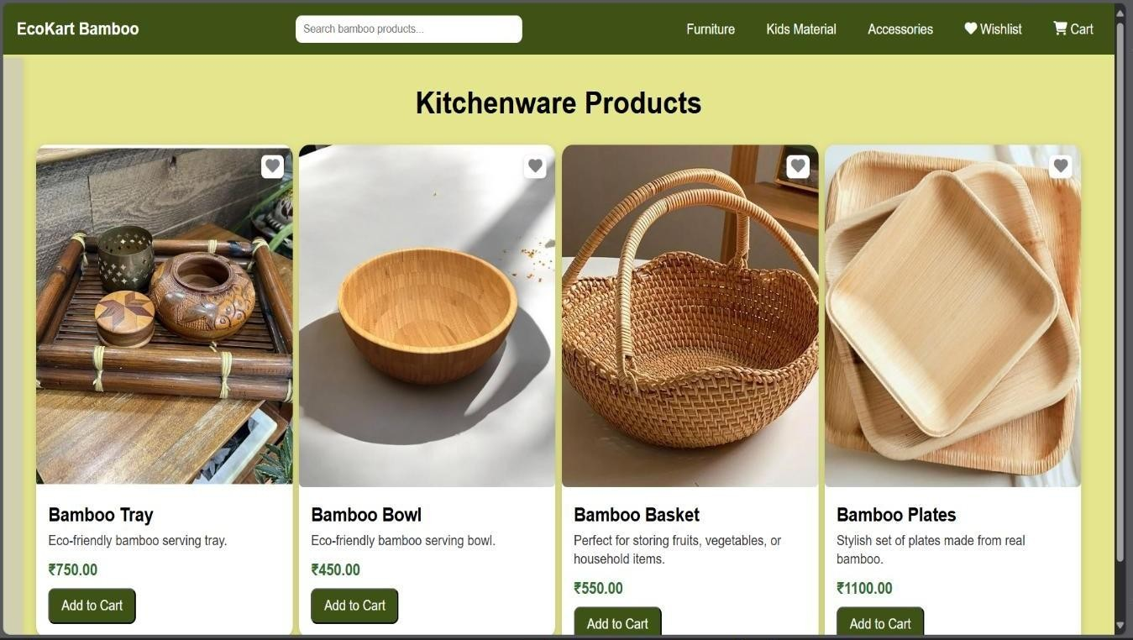

* 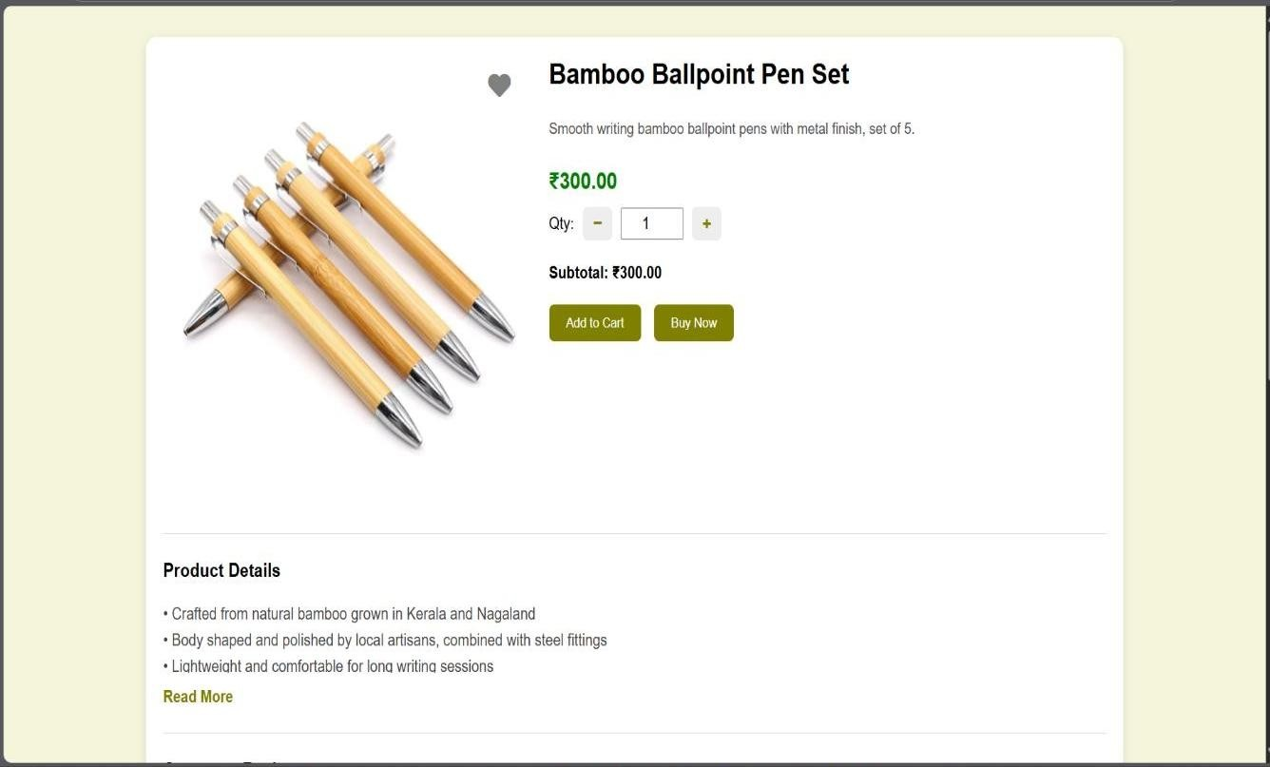Product detail page:

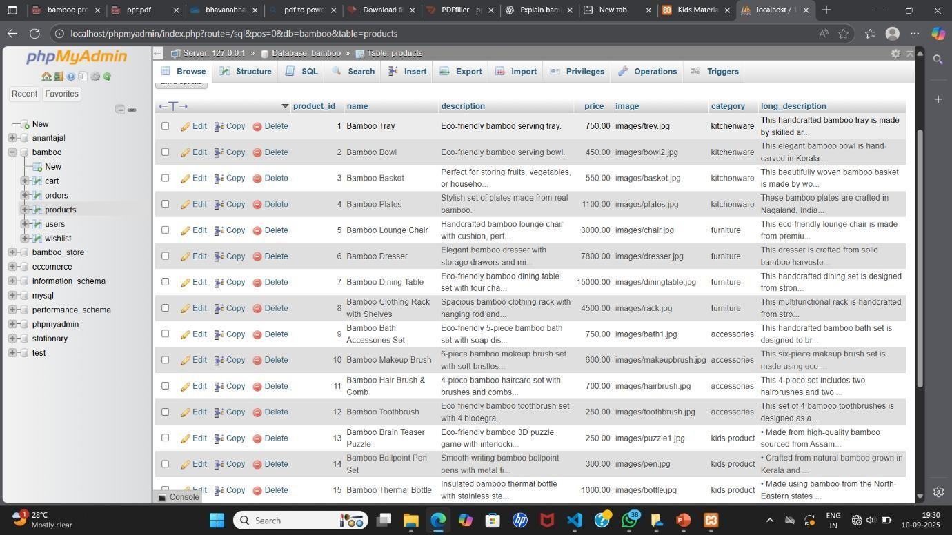

* Database of Product Page:

## 3. Cart & Wishlist Checkout

* Users can add products to cart, change quantity, or remove items.
* Users can add products to wishlist, or remove items.
* 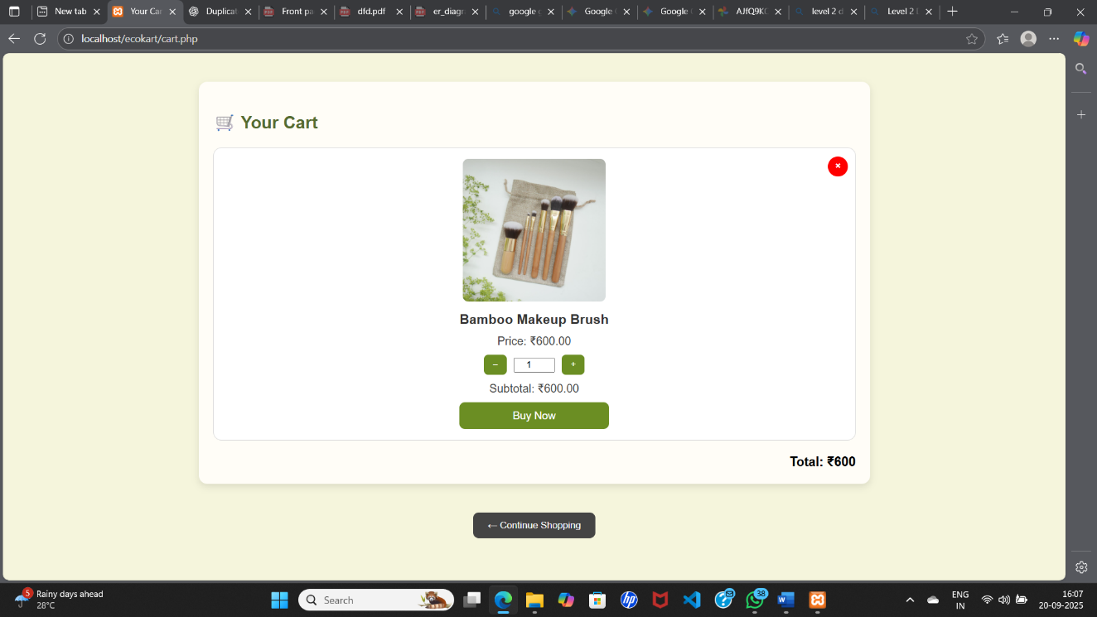Cart page:
* Database of Cart page:

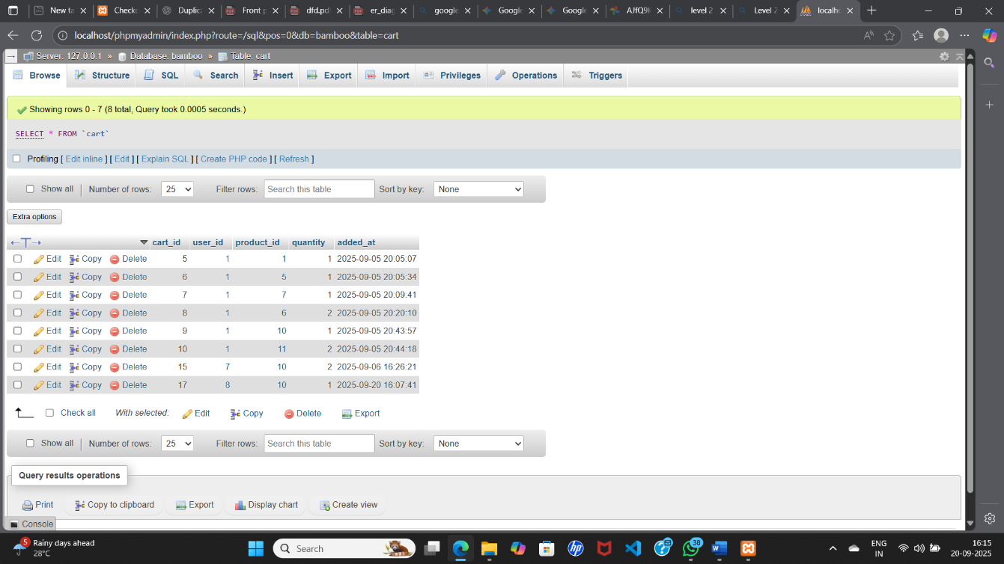

* Wishlist page:

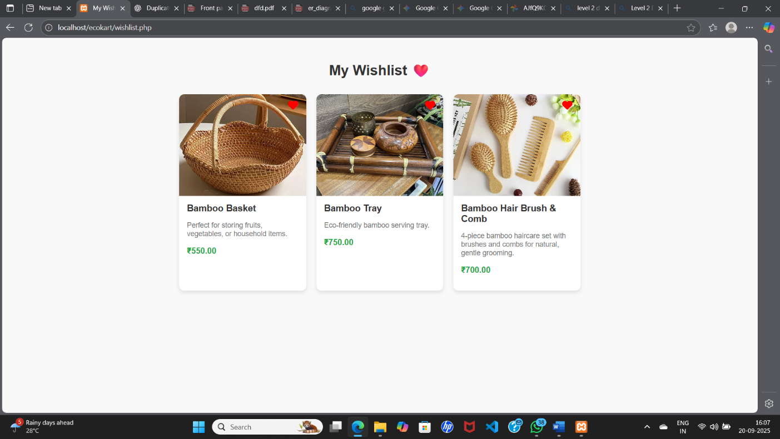

* Database of Wishlist page:

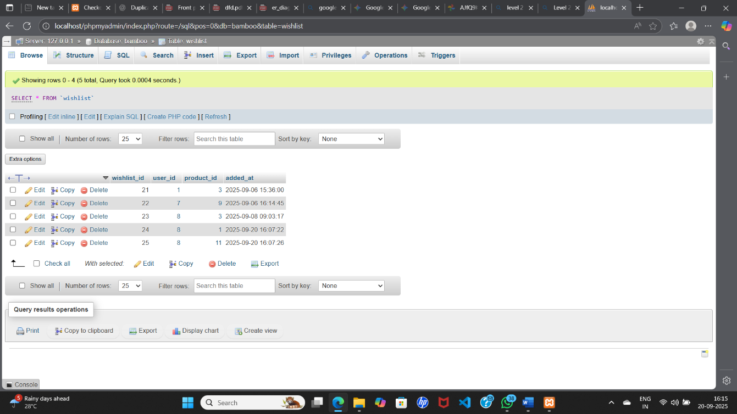

**4.Checkout**

* Checkout page shows total price, delivery address, and payment option (offline cash payment).

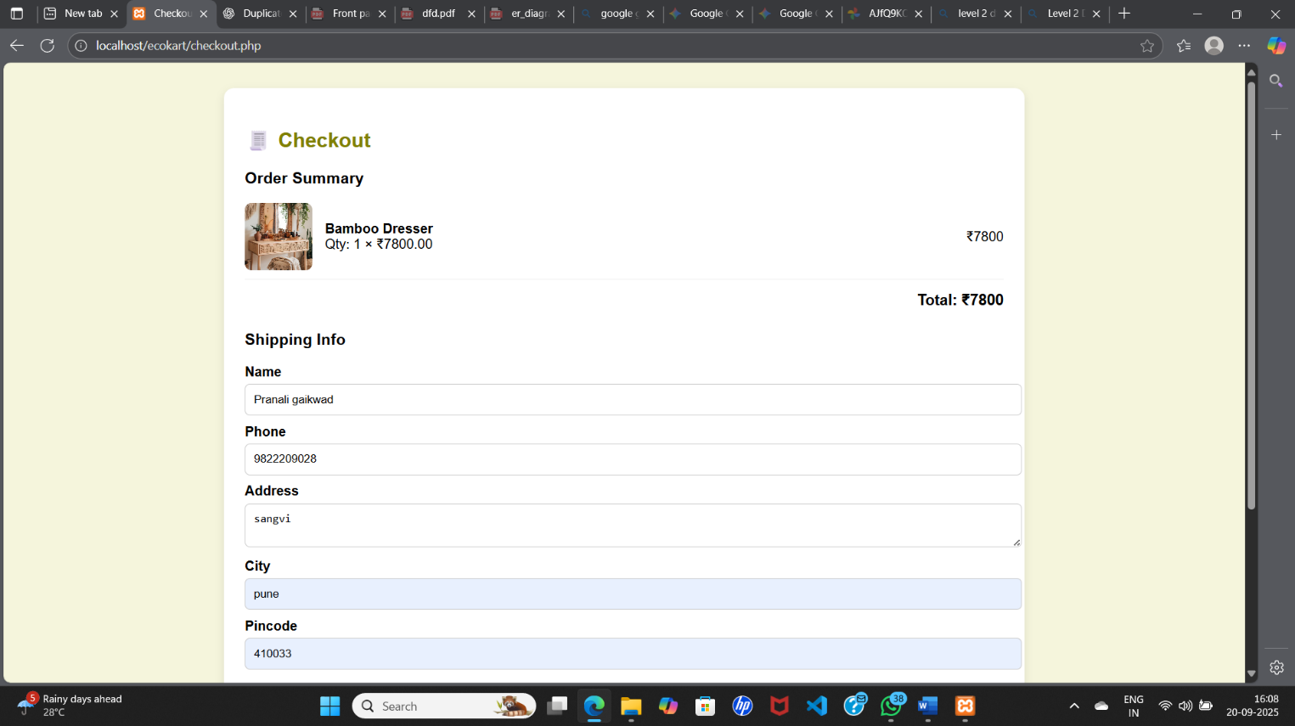

* Order confirmation:

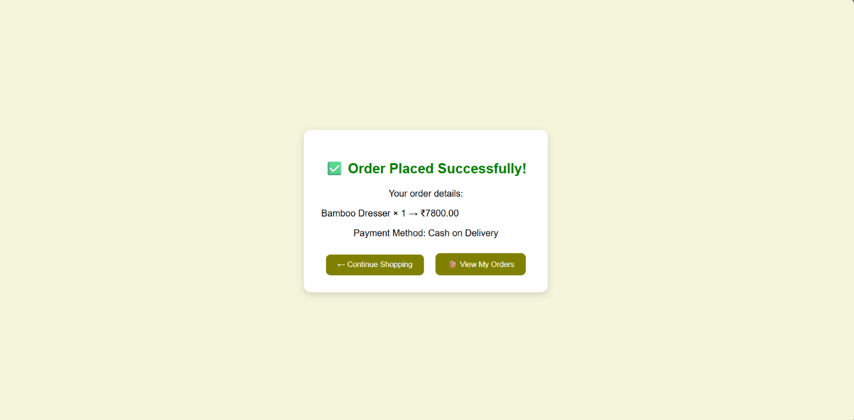

5.Login/Register Pages

* Login Page: Users enter username and password to sign in.
* 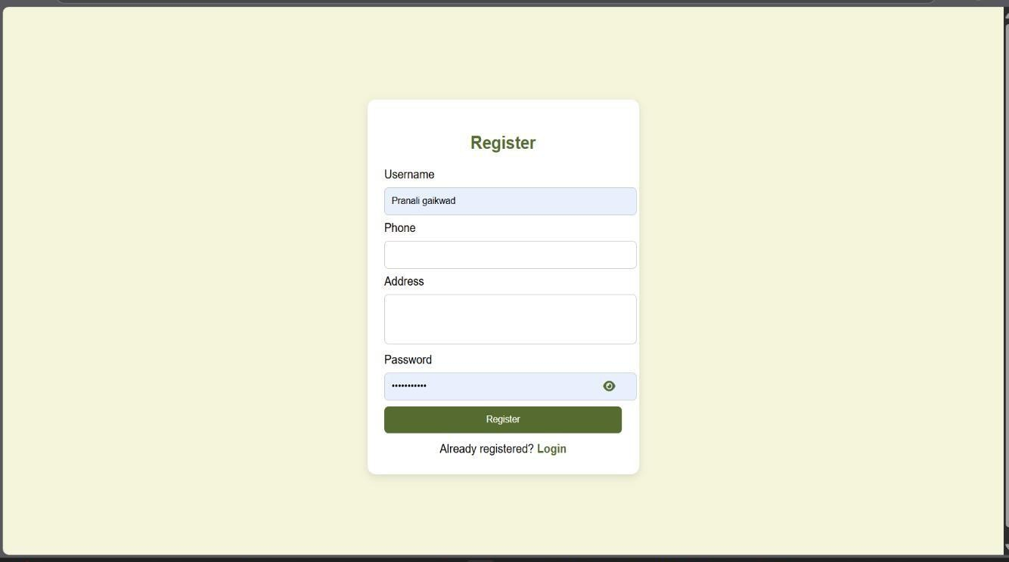Register Page: New users enter name, address, password, and contact details**.**
* Register page:
* 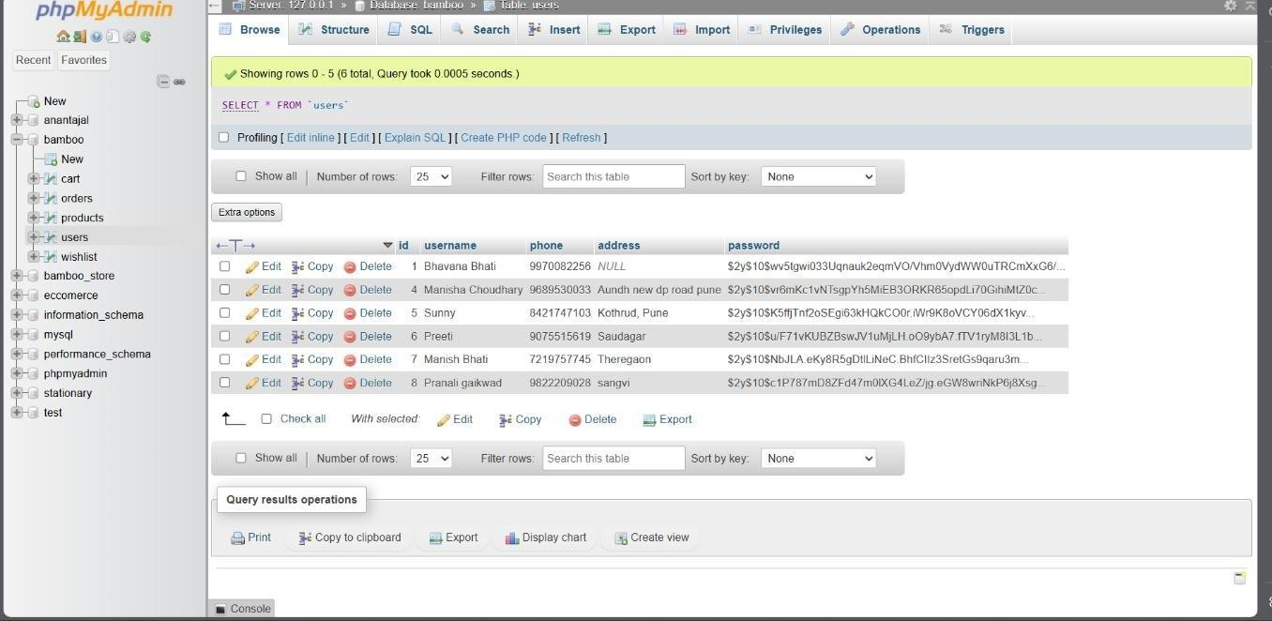Database of User Registration page:

# 5. Implementation Details

Implementation involves selecting suitable technologies for development, ensuring scalability, and providing a secure user experience.

**5.1 Software and Hardware Specifications:**

Software Requirements:

* Frontend: HTML, CSS, JavaScript.
* Backend: Node. PHP, MySQL
* Database: MySQL

Hardware Requirements:

* Minimum 8GB RAM server.
* Cloud hosting support (Google Cloud).
* Client devices: PC, smartphone with internet connectivity.

# 6. Testing

Testing ensures that the Bamboo Product Selling System functions correctly, securely, and efficiently

**6.1 Test Plan:**

* Verify user login, product browsing, wishlist, and order placement.
* Validate admin features like adding products.

**6.2 Black Box Testing / Data Validation:**

* Check user login with valid/invalid inputs.
* Verify product selection and order placement.

**6.3 Test Cases**

Test Case 1: User Registration

* Input: Valid user details (Name, Number, Password).
* Expected Output: User account created successfully.
* Actual Output: User account created.

Test Case 2: Product Search

* Input: Keyword “Bamboo Chair”.
* Expected Output: System displays a list of bamboo chairs.
* Actual Output: List of bamboo chairs displayed.

Test Case 3: Login with Wrong Password

* Input: Valid email + wrong password.
* Expected Output: Error message “Incorrect Password”.
* Actual Output: Error message displayed.

Test Case 4: Add Item to Wishlist

* Input: Select product → Click “Add to Wishlist”.
* Expected Output: Product appears in wishlist page.
* Actual Output: Product appeared in wishlist page.

Test Case 6: Add to Cart

* Input: Select a product → Click “Add to Cart”.
* Expected Output: Product appears in cart with correct name, price, and quantity.
* Actual Output: Product appeared in cart with correct details.

**6.4 White Box Testing / Functional Validation:**

* Validate code for secure password handling.
* Check product retrieval from database.

**6.5 Test Results:**

* All modules tested successfully with valid inputs.

# 7. Conclusion and Recommendations

**Conclusion:**

The Bamboo Product Selling System is a useful solution for promoting ecofriendly products and supporting farmers. It reduces the use of harmful materials like plastic and wood by providing bamboo as a better option. The system also helps in organizing the bamboo market, making it easier for sellers to connect with buyers. This not only improves sales but also spreads awareness about the benefits of bamboo. Overall, it is a step towards protecting the environment and encouraging sustainable living.

**Recommendations:**

1. Awareness Programs – More campaigns should be done to make people understand the importance and uses of bamboo products.
2. Fair Trade for Farmers – Ensure that farmers get a good price for their hard work by removing middlemen.
3. Online Selling Platform – The system should have an online platform so products can reach more customers easily.
4. Quality Improvement – Provide training to bamboo craftsmen to make strong, modern, and attractive products.
5. Government Support – Policies and subsidies should support bamboo based industries to grow faster.

# 8. Future Scope

In the future, our Bamboo Products Selling System can grow in many ways. The product range can expand to new items like bamboo tiles, bicycles, and eco-packaging. We can sell products globally through exports and e-commerce platforms like Amazon and Flipkart. A mobile app can be developed for easy shopping and tracking. Farmers can be supported with training, and new jobs can be created in rural areas. Bamboo can also be used in green construction like flooring and panels. With government support and eco-certification, bamboo products can become a strong alternative to plastic and promote a Plastic-Free India.

# 9. Bibliography and References

**Research on E-commerce Platforms**

* Amazon – https://www.amazon.in
* Flipkart – https://www.flipkart.com
* **www.bamboomarketplace.org**

**Academic Study Material**

* Software Engineering by Mrs. Manisha Suryavanshi & Dr.A.B.Nimbalkar
* Web Technology by B.Taunk & Aniket Nagane
* Relational Database by Dr.Ms.M.Bharambe & A.D.Mankar
* *PHP by* Prof. Gajanan A. Deshmukh and Mrs. Swati S. Jadhav.